1. 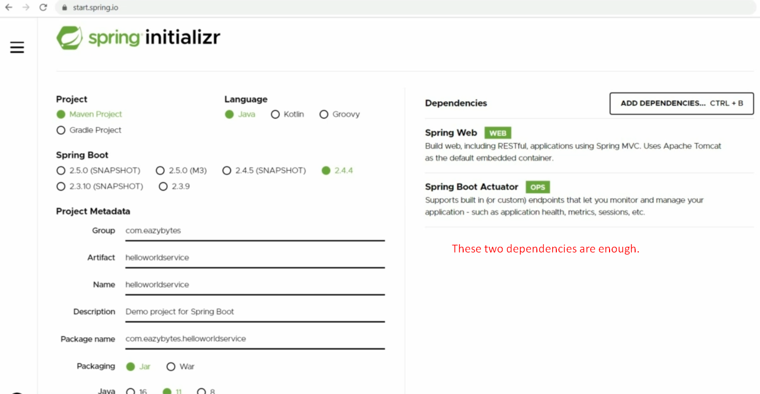
2. 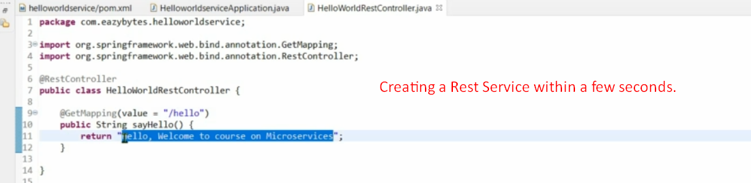
3. 
4. We can also check metrics and health status using actuator.
5. 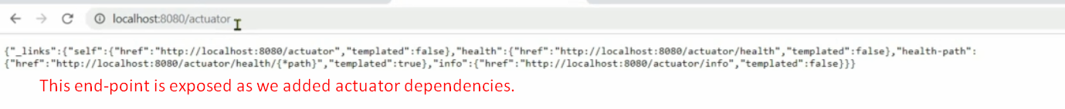  
   By default only two end-points are exposed 🡺 /health, /info
6. 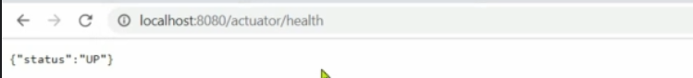
7. 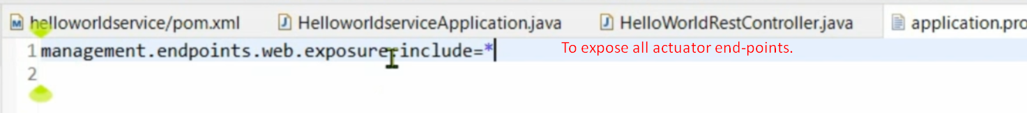
8. 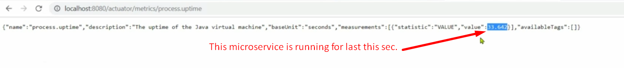
9. 